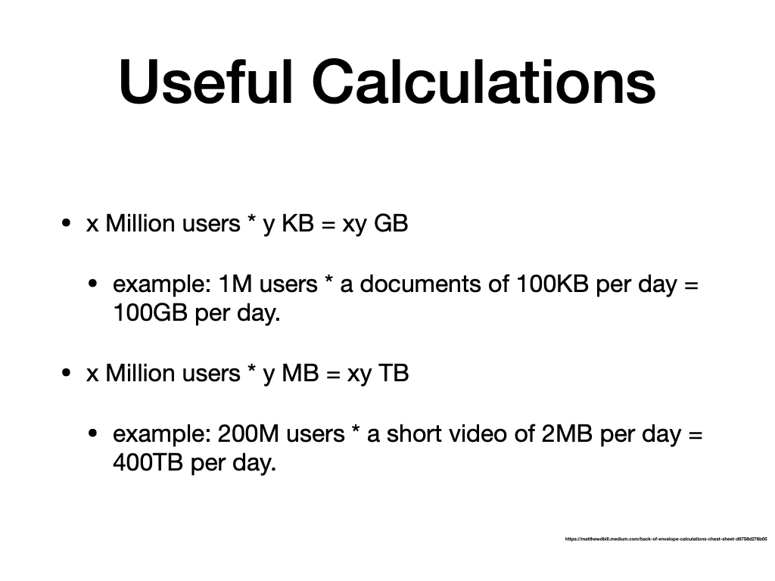

* File: 100 KB
* Web Page: 100 KB (not including images)
* Picture: 200 KB
* Short Posted Video: 2MB
* Steaming Video: 50MB per minute
* Long/Lat: 8B
* Maximum URL Size: ~2000
* ASCII charset: 128
* Unicode charset: 143, 859